Project Lifesaver,
Chapter One – The Beginning

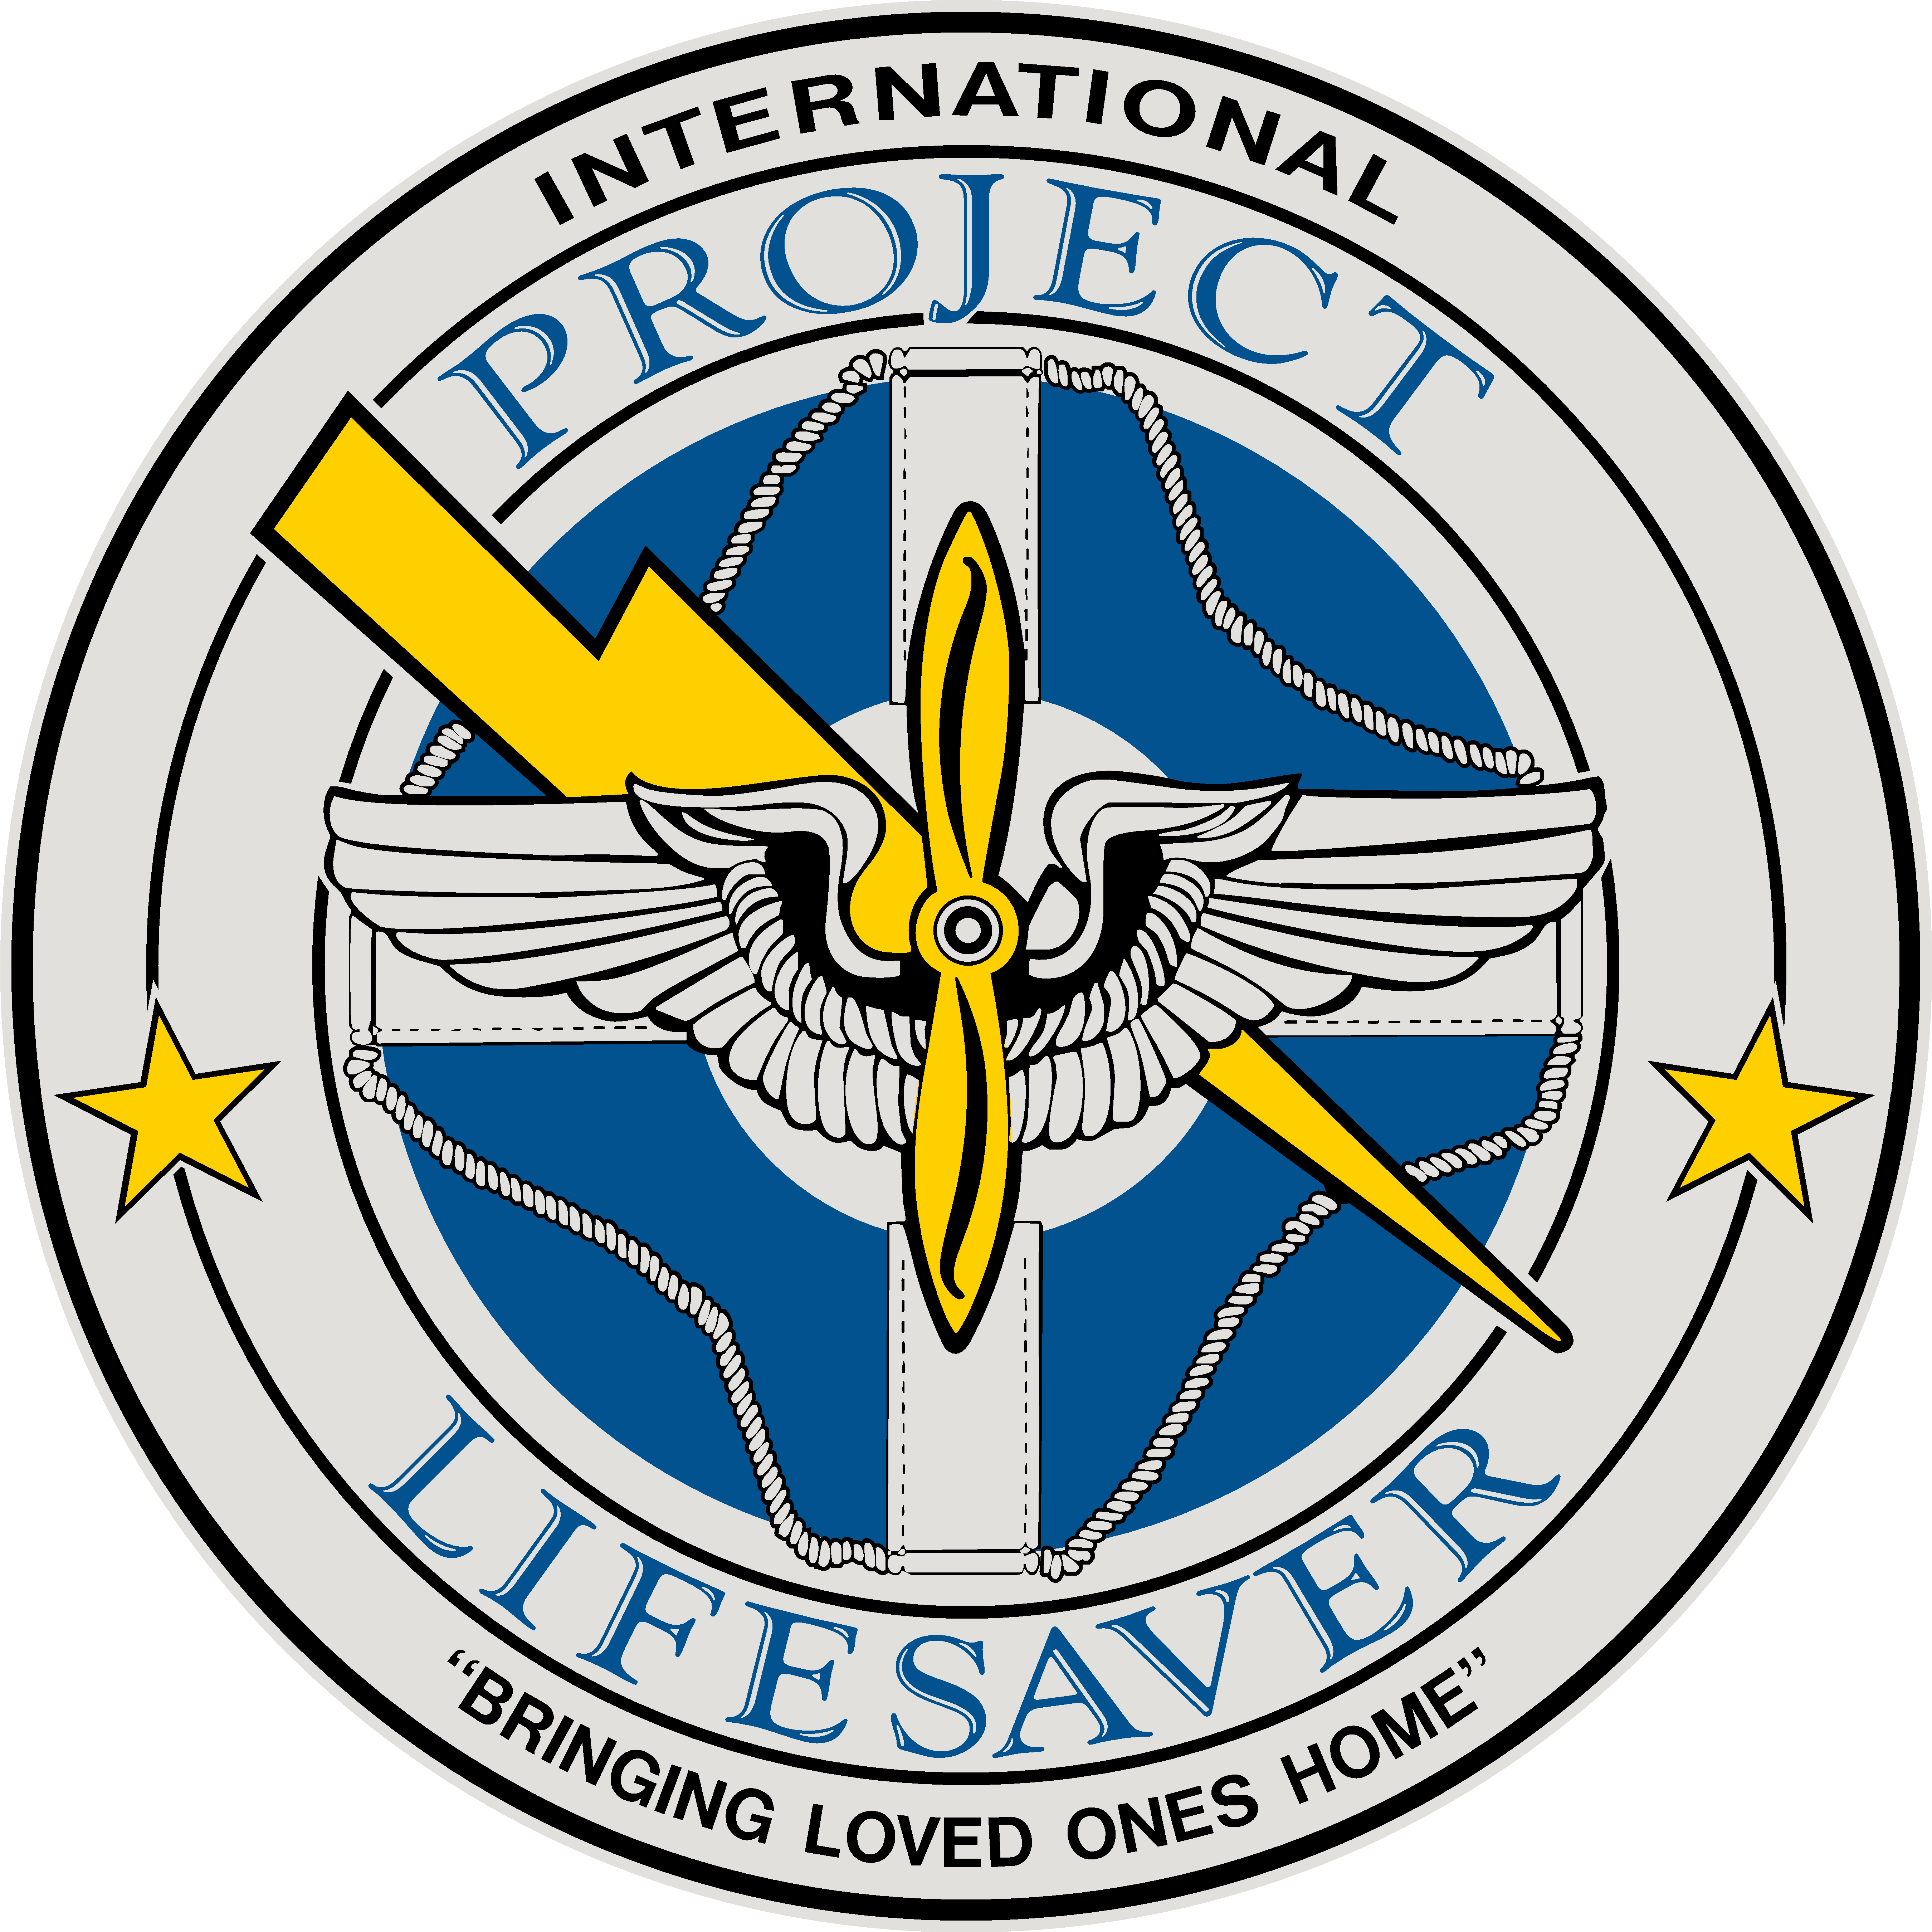

Gene Saunders, CEO/Founder

Many times I have been asked about how Project Lifesaver started and to document the beginnings to present date. Frequently, I have recounted the story verbally but never wrote it down in detail. Based on some of the requests I have had in the recent past and to document the story for future use, I feel inclined to put “The Beginning” in print and let people know exactly how Project Lifesaver started.
I began Project Lifesaver while part of the 43rd Virginia Search and Rescue of the Chesapeake Sheriff’s Office. However, the 43rd actually began from several other units that date back as far as 1985. In 1985, I became a member of the Virginia State Militia - which was a volunteer section of the Virginia National Guard. At that time, I was asked to take command and raise an aviation unit with 40 personnel and approximately 12 available aircraft that we could call on at any time.
During this time, the infantry unit, The Lafayette Brigade, came into existence and because my basic interest had always been in infantry and airborne, I requested and received permission to transfer to infantry. While doing so, I had a conversation with Brigadier General James Dingus, the Commanding Officer of the Lafayette Brigade at that time. He, on learning of my Ranger and Special Operations background, asked if I would form a Ranger unit charged with search and rescue, as part of the brigade. I recruited approximately 60 personnel which were all veterans of the military from Special Forces (such as airborne, seals, rangers, and other units) as well as others that were part of the special operations community.
I commanded the Rangers from 1987-1988, at which time I was promoted and transferred to Executive Officer of the 3rd Battalion, Lafayette Brigade. About the same time, there seemed to be a shift in the philosophy of the Virginia State Militia. In fact, it was renamed the Virginia Defense Force and a new general was brought in to command the organization. His philosophy was to eliminate all operational units and become a caretaker for the armories if the National Guard was called into active duty. This philosophy did not align with the beliefs of the members of my unit, as they were volunteering to be operational and productive. Knowing this was coming, I started searching for a new place where our skills would be an asset. After talking with the U.S. Air Force Auxiliary, also known as the Civil Air Patrol, we were accepted and embraced immediately. From there, we transferred over from the Virginia Defense Force as a unit to the Civil Air Patrol as a Senior Squadron (Ranger). This meant we had no cadets, nor would our unit receive cadets within our organization. We were with the Civil Air Patrol until 1992, and during this time, a large amount of promises were broken. The members of the unit asked me to see if I could find another place for them as they wanted to continue their mission and keep the organization together.
I then had a conversation with Sheriff John R. Newhart of the Chesapeake Sheriff’s Office asking him if he would like to have an intact Search and Rescue Unit. He responded that he certainly would. The organization then left the Civil Air Patrol and became a part of the Chesapeake Sheriff’s Office, as a volunteer auxiliary known as the 43rd Virginia Search and Rescue.
Quickly the 43rd Virginia Search and Rescue gained a reputation of being a “can do” organization that had no problem operating in the roughest of terrain. In fact, the Virginia Council for Search and Rescue, in their missions, would often call the 43rd to come in and handle areas that they considered “ranger missions” - covering the toughest, most arduous terrain you could find within the state. The unit was successful on many searches and gained a very favorable reputation. Many of the searches we embarked on were Alzheimer’s patients and we were not always successful in finding them before harm befell them. The unit also went on a number of disaster relief missions, including several hurricane relief missions up and down the East Coast.
In 1998, the Sheriff went to a National Sheriff’s Association conference. At these conferences, there are many vendor booths and material is picked up by the sheriffs to be studied later when they come home, concerning equipment and programs which may be beneficial to their agencies. It was my understanding that this material was given to the Undersheriff, Lt. Colonel David Newby, who parceled it out to the persons he thought might have interest in it. He sent me a brochure concerning wandering and electronic tracking equipment. While looking at this material, reviewing it, and knowing some of the failures and problems we had on Alzheimer’s searches in the past, I decided to take a closer look. I thought that if we could develop a program where we could track Alzheimer’s/dementia patients, it would certainly help us. I thought the program would be most valuable in the areas of saving money, time, and resources by rescuing people quickly and safely and returning them to their loved ones unharmed.
With these materials in hand, I met with Benny Rogerson, my Executive Officer at that time, and we talked about my ideas a great deal. We also researched the use of the equipment by a group in North Carolina known as the Stokes County Mountain Rescue. They had done some work with nursing homes in the area and had pretty good success in tracking wanderers in about 12 searches. I went and studied their procedures and equipment and decided this could be beneficial. However, I wanted to change a few things with the way things were being run. I believed this equipment should be made available to private homes and nursing homes, and that the Sheriff’s Office should be the responding unit - as law enforcement is often the first responders to any search and rescue mission.
Next, I took my idea to Undersheriff Dave Newby explaining that I thought this would be a good program to implement. He agreed, and during the conversation I suggested we talk with Sheriff Newhart to see if he would approve my going forward. After speaking with Sheriff Newhart, he approved it and now the only trick was to raise the money to fund it. I called a number of the local groups in the area that work with Alzheimer’s and dementia patients and asked to have a meeting with them. This included local hospitals and the Alzheimer’s Association. In fact, during one of these meetings the name Project Lifesaver was born. Benny Rogerson actually came up with it after hearing one of the hospital representatives make the remark that this program would be a “lifesaver” and “Project Lifesaver” was born as an acronym. Shortly after, we developed the training, equipment, and search procedures for our program for personnel to use. I approached a local hospital to obtain funding to do a pilot program within the area. They granted me $88,000 to do a 15-month pilot program.

In April 1999, we held a press conference in the Sheriff’s Office and shortly thereafter on April 9, 1999, I placed the very first transmitter in the Project Lifesaver program on a gentleman who lived in Virginia Beach and suffered from Alzheimer’s disease. We continued with the program and our training, and we continued to add clients. In July, we had our first search. We actually recovered that gentleman in a little over a minute and a half. This search demonstrated to me that the program had the potential to be successful and could possibly be a huge benefit to communities.

We started receiving calls from surrounding areas and across the state of Virginia concerning the program. The first call and training program was Pittsylvania County Sheriff’s Office. Benny Rogerson and I taught the Sheriff’s Office on our procedures and soon after, they implemented their own program. During the training, one of the deputies made a very prophetic remark, stating that he believed this would become “a road show.” How true those words were.

As time continued, more and more requests for training came in, not only within the State of Virginia but outside the state as well. Now Benny Rogerson and I were traveling, often doing the training, while still full-time employees of our respective police departments - Benny as a Captain of the Norfolk Police Department and I as a Captain with the Chesapeake Police Department. We found that our leave and vacation were dwindling away at a rapid pace. In 2000 I decided, with the permission of my wife, to retire and take on Project Lifesaver full-time. I fully believed in the success of this project, if only I could devote more time to the program and traveling to communities.

In February 2001, I retired from the Police Department - becoming the only full-time employee working for Project Lifesaver. Shortly thereafter, I was able to bring on one administrative staff member, Sharon Proffitt, who worked about 3 hours a day and helped with paperwork and other administrative tasks while I was still on the road continuously, training organizations.

On consulting with our lawyers, shortly after going full-time with the organization, it was determined that in order to continue implementing the training and establishing the program with Sheriff and law enforcement agencies, we needed to change our structure and separate from being part of the government. I then submitted paperwork to the State of Virginia and incorporated Project Lifesaver as a non-profit organization in November of 2001. Shortly thereafter, I submitted information to the federal government for permission to become a 501-©3 charitable organization, which was granted.

Since that time, the Project Lifesaver program has grown steadily. We have added other conditions under our program which we cover, including autism, Down syndrome, and any other cognitive conditions that may lead to wandering. We have had many ups and downs, obstacles and successes - those I hope to share with you in future writings. And so concludes Chapter One of my story...

Thank you!
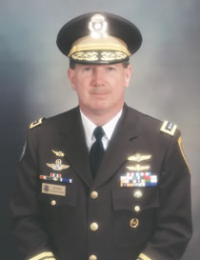
Gene Saunders
Chief Executive Officer/Founder

